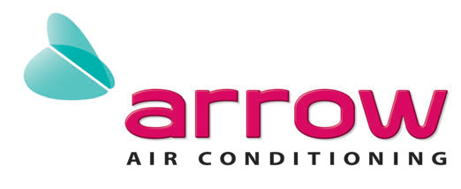

September 12, 2017

Attn: Jenling Real Estate Phone Number: 0405 630 403

Head Office

2/45 Bay Road

Taren Point NSW 2229

## Repair Quotation

**RE: 57 Botanica Drive, Lidcombe NSW 2141**

Following the inspection of the air conditioning system, I am submitting this quotation for the replacement of the faulty outdoor fan motors and blades.

**Inclusions:**

- Replacement of the outdoor fans motors

- Replacement of the outdoor fan blades

- Labour and testing

**PRICE – PARTS & LABOUR - $930.00**

**Includes GST**

*Please note – 50% deposit will need to be paid and received before parts are to be ordered. Once we have approval, I will issue the invoice and when monies are received the parts will be ordered.*

I hope that this quotation is sufficient for your requirements. Should you require any additional information, please do not hesitate to contact me and I will be happy to assist you.

Yours sincerely,

Alanah Springett

………………………………………………………………………………………………………………

I approve to proceed with the quotation.

…………………………………………… ……………………………………………..

Name: Signature:

……………………………………………

Date: